Consistency – to ensure a product is intuitive for the user, aesthetically pleasing and promotes brand recognition

Information hierarchy – to navigate the product more easily

Visual hierarchy – to enable more important content to stand out

Confirmation – to ensure the user is aware of any actions performed and their impact

User control – to allow navigation of the product, efficient workflow and error correction

Accessibility – to ensure the product is appropriate for a wide range of users

This shows twitch’s consistency as it shows their brand name at the top left making sure it promotes their brand and letting people know the software that they are on. It provides a great user experience as it shows many different livestreams as well as letting you choose a category to browse through. It can be very easy to navigate even without much knowledge.

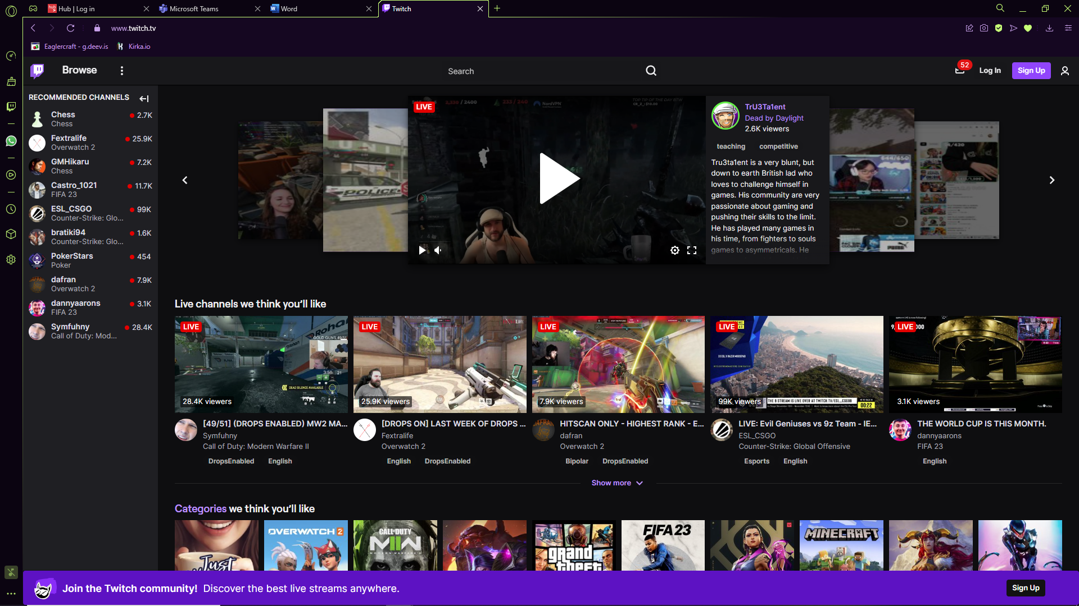

Twitch has a great information hierarchy as it allows its users to navigate and find different genres that a new user might want to watch, making it easy to find something of interest to them by showing all of the popular categories at the top. In my opinion, it provides a good user experience as the popular categories can be found quickly, and it’s all in one place, making it easier to navigate.

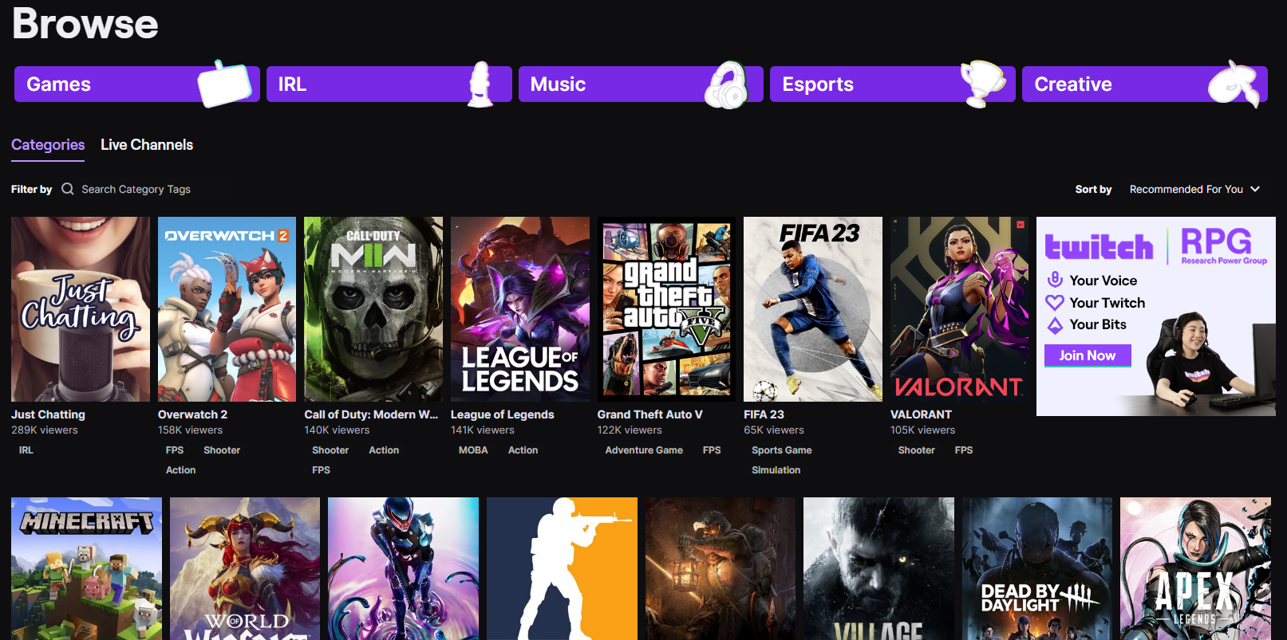

Twitch does a good job in their visual hierarchy as it displays the most popular categories making it easy for a new user to see what’s trending at the time of the visit. This makes up for a good user experience, however I believe they should add the streamers with the most views as well to make it easier for a new user to find a good popular streamer

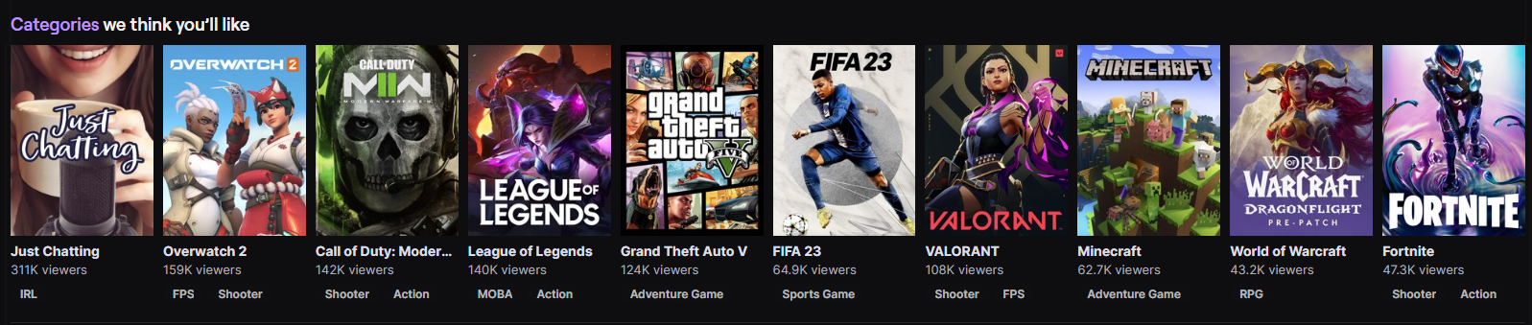

If you pay attention to small details on twitch, you will find that they use confirmation in many ways. One example is that when hovering over a livestream, it slides up a little and creates a purple highlight on the side, making it visible to what livestream you are about to click on. I think there’s nothing that needs to be added to make a better user experience.

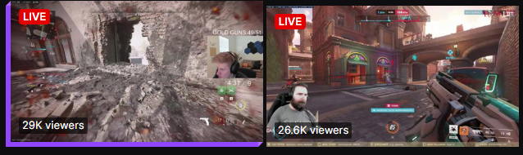

On twitch, when you try searching for a specific streamer, it will let you know if the person doesn’t exist, and it’ll take letters from your search and give appropriate feedback of channels and videos. This makes twitch have a good user experience as even if you type a streamers’ name wrong, it’s likely to find it by the letters used in the search, making it easy to find specific streamers.

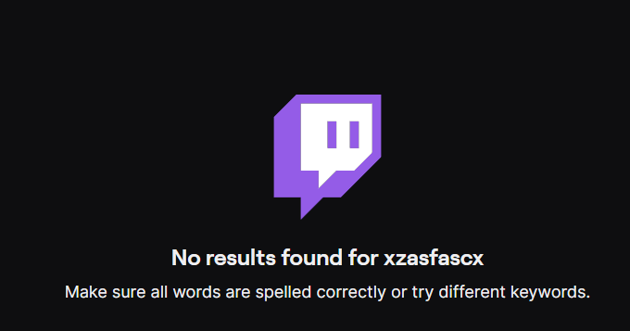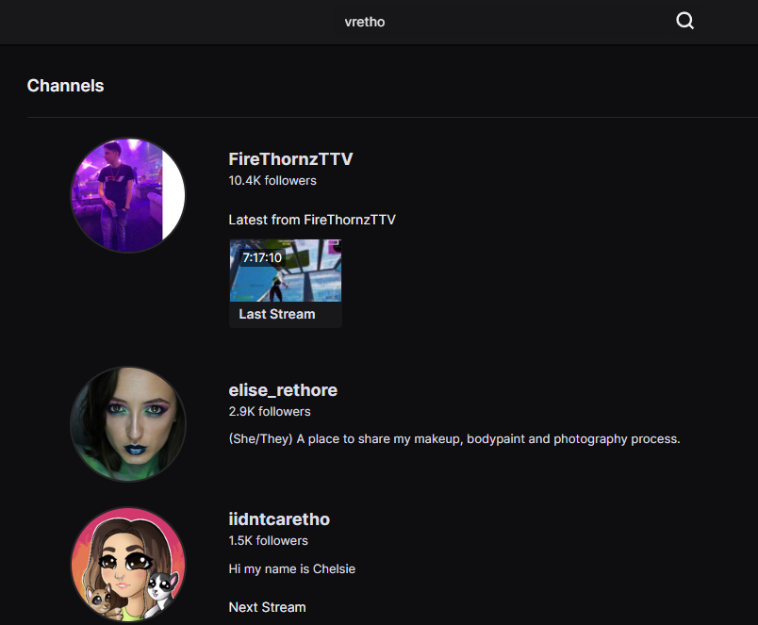

One accessibility settings twitch has is the ability to change the language, allowing people that don’t understand a language to switch to one they understand. This is very easy to find as well allowing for good user experience as they can use the software more easily in their own language.

